**A PROJECT REPORT ON**

**e-PANJEEYAN FOR REVENUE & DISASTER MANAGEMENT, GOVT OF ASSAM**

**niclogo.png**

**An android application submitted** **in partial fulfillment for the award of the Degree of**

**Master of Computer Application (M.C.A.)**

**Dibrugarh University, Dibrugarh (Assam)**

**Session: 2016 – 2019**

# Under the guidance of

Internal Guide Organizational Guide

**Mr. Joydip Kumar Sarmah Mrs. Hiramani Goswami**

Associate Professor & HOD Senior Technical Director

Department of Computer Applications Assam State Centre, Dispur Jorhat Engineering College National Informatics Centre

**Submitted By**

**Dipsikha Phukan**

Roll No: MCA 12/16

Reg-No: 13931934 of 2013-2014

MCA 6th Semester

Jorhat Engineering College

Jorhat, Assam

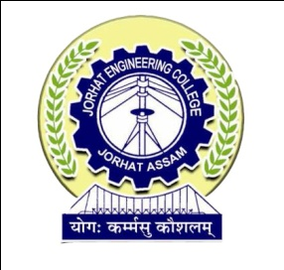

**DEPARTMENT OF COMPUTER APPLICATION**

**JORHAT ENGINEERING COLLEGE, JORHAT**